**Route Tokens**

The route tokens [controller], [action] can be used to apply common-patterned routes for all action methods.

The route of controller acts as a prefix for the route of actions

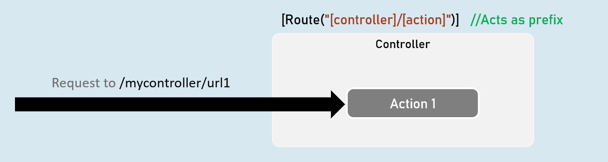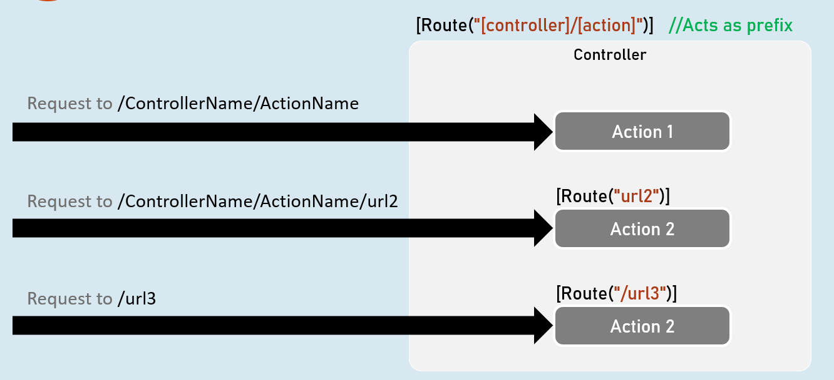

**Attribute Routing**

[Route] attribute specifies route for an action method or controller.

The route of controller acts as a prefix for the route of actions.

**[Route] - Attribute Routing**

